Date: 30/11/2022

Method Statement
Project Name | High pressure combustion Test centre
Client Name | ATD combustors/KU
Main Contractor | ATD Combustors
Civil Contractor | Excel Tiles
Location | Lab 028

Scope of Work:
Pump Room:
- Make foundation (200 mm high, 120x 100 mm) and install pump in the pump room
- Connect piping to suction tank and to discharge line in pump room
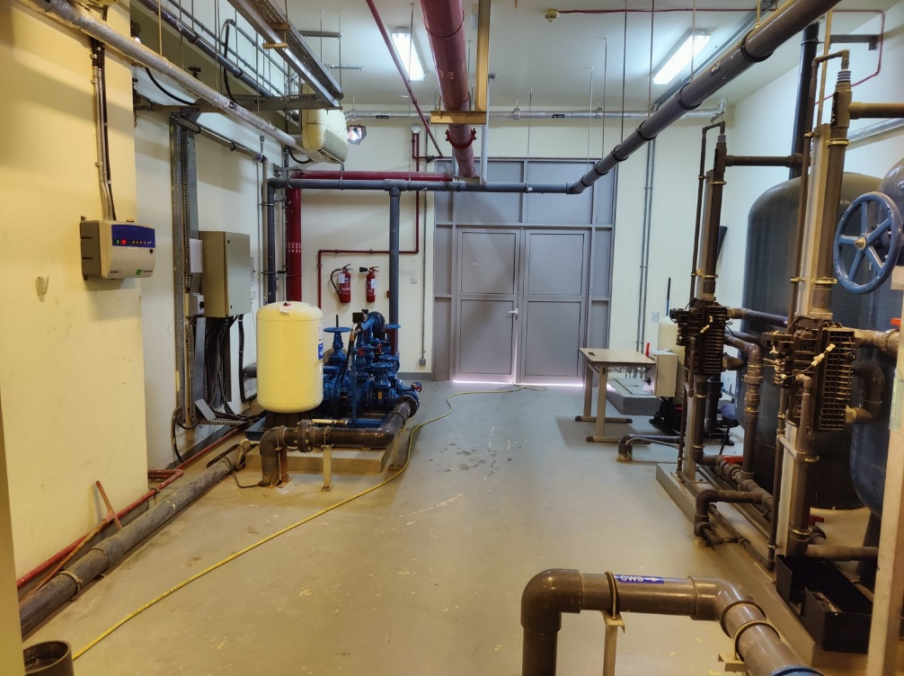

Lab 028:
- Make foundation and install pump in the labA028
- Connect piping from water taps
- Make hole bigger for exhaust piping outlet from labA028

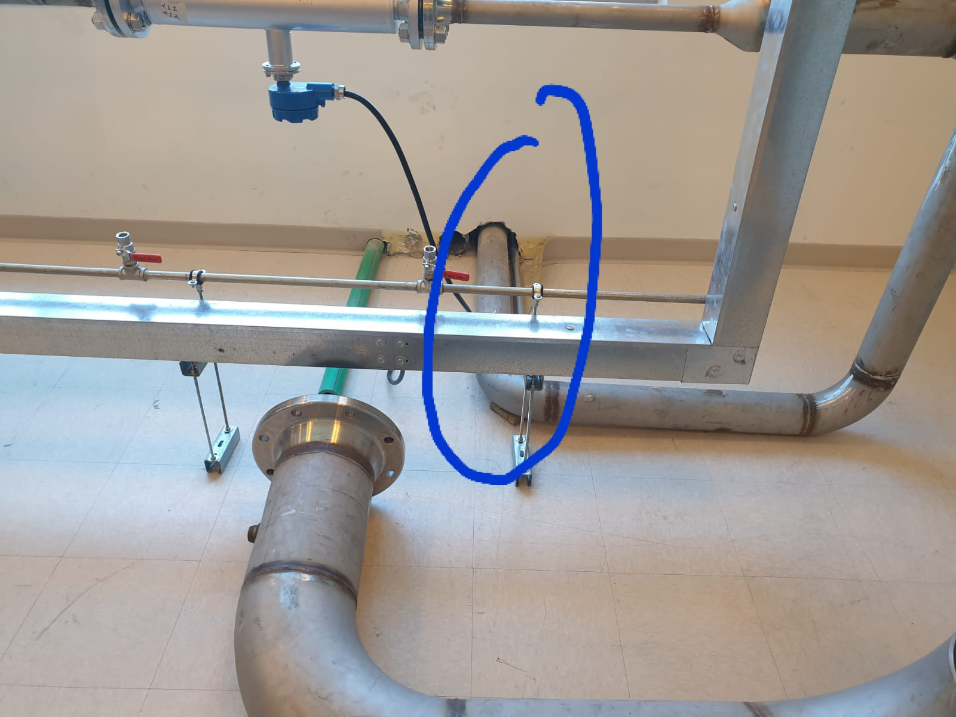
Make opening for 6” pipe.
After pipe installation, remaining wall closed
Make foundation
45x45 mm.100mm high

Compressor Room
- Erect storage tank and make anchor bolts
  - Mark location for anchor bolts. Drill 3 anchor bolt hole.
  - Open panel from top. Use crane to lift the tank.
  - Align the tank as per hole and instal anchor bolts
- Install grill and exhaust Fan in compressor room

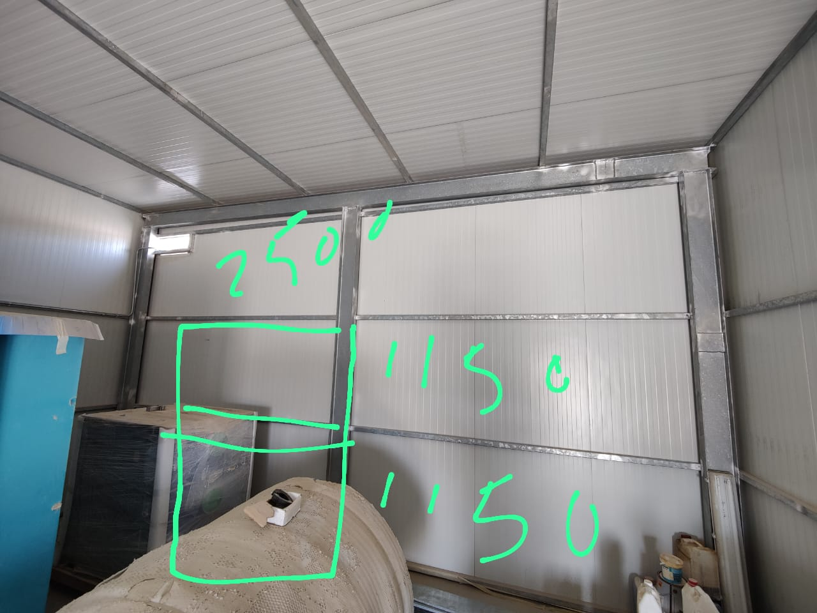

Activities
Drilling
Drilling for tank with normal drill machine using hand gloves , safety glasses and safety shoes
Lifting
Lifting stuff with boomloder with belt with all safety measures
Civil work
Use hilty for making hole under window , gloves ,safety glasses
Piping
Fixing PPR pipes with heater ,
Gloves, Fire extinguisher
Foundation
Using Ready mix concrete, safety gloves

Regards
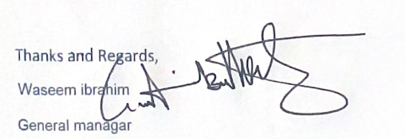

Ph: 056-4951761

